National High Magnetic Field Laboratory Digital Lock-In Reference Schematic Drawings and Connection Functions

Albert Migliori

30 Aug 2009

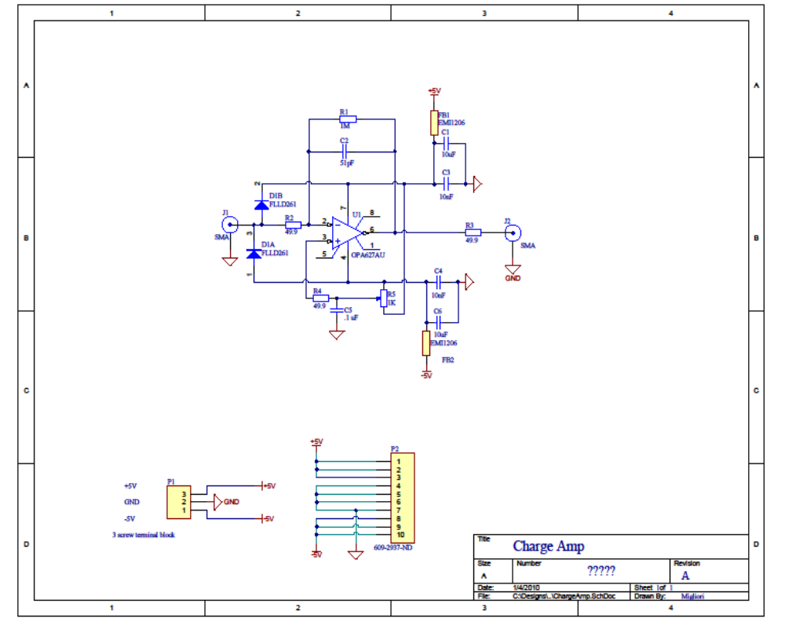

B. Triple Synthesizer
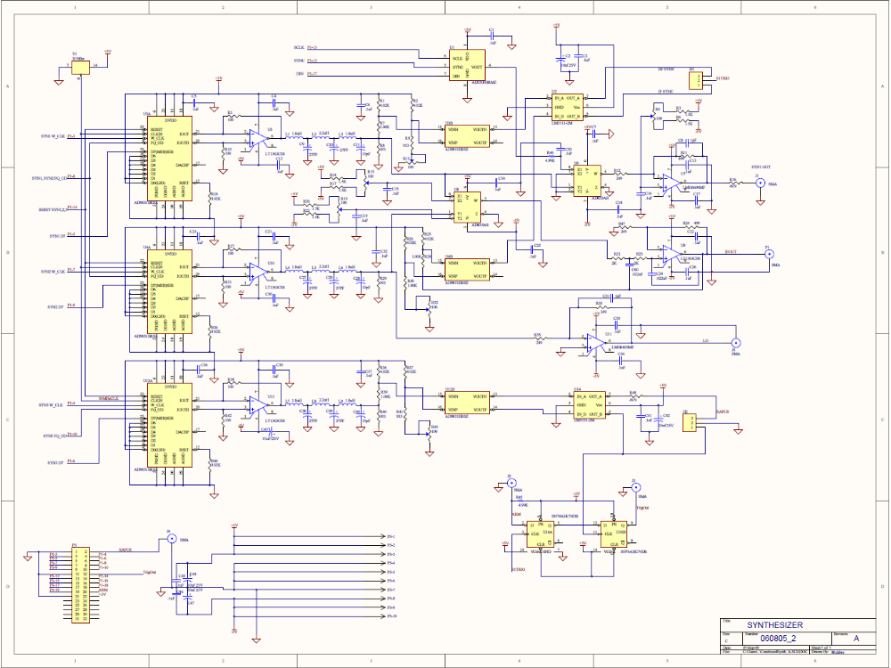
P1 3 through P1 10 and P1 14 are named for function exactly as the AD9851 data sheet calls out.
P1 13, 15, 17 are exactly as the AD5300 series calls out. Some boards may have the 12 bit chip, others the 8 bit chip. This is a serial interface to set the amplitude of syn1.
P1-12 and J3 are the synchronization trigger out.
P1-20 and J2 are the trigger arming input.
P1-2 and J4 are the digitizer clock drive output.
H2 has Clock and Clock on its pins as well as ground. Do not short outputs to ground.
R13, R32, R43 set tthe duty cycle of square wave outputs for each synthesizer.
R15, R19 set the double balanced mixer to eliminate anything but the sum and differences.
R4 is the DC offset trim for Syn1.
H1 sets the trigger to sync off either the IF (P1) or the RF (J1)signal.
6501 Synth 6251
Function J1(signal, pin) P3(pin) P1(signal, pin for 50 pin Digital I/O)
Syn1 w clk P0.0 17 3 P0.0 1
Syn1 D7 P0.1 19 5 P0.1 3
Syn2 w clk P0.2 21 7 P0.2 5
Syn2 D7 P0.3 23 9 P0.3 7
Syn3 w clk P0.4 25 4 P0.4 9
Syn3 D7 P0.5 27 6 P0.5 11
Syn1,2 FQ_UD P0.6 29 8 P0.6 13
Syn3 FQ_UD P0.7 31 10 P0.7 15

Reset 1,2,3 P1.3 7 14 PFI 3 23

SCLK P1.0 1 13 PFI 0 17
SYNC P1.1 3 15 PFI 1 19
DIN P1.2 5 17 PFI 2 21

GND GND 2 1 GND 2

Trig_arm J2 PFI 4 25
Trig J3 PFI 5 27
A/D_clock J4 PFI 7 31

Analog channels
RUS_sig Mixer out AI 0 11, 13(GND)
Ref_sig IO out AI 2 17, 13(GND)

